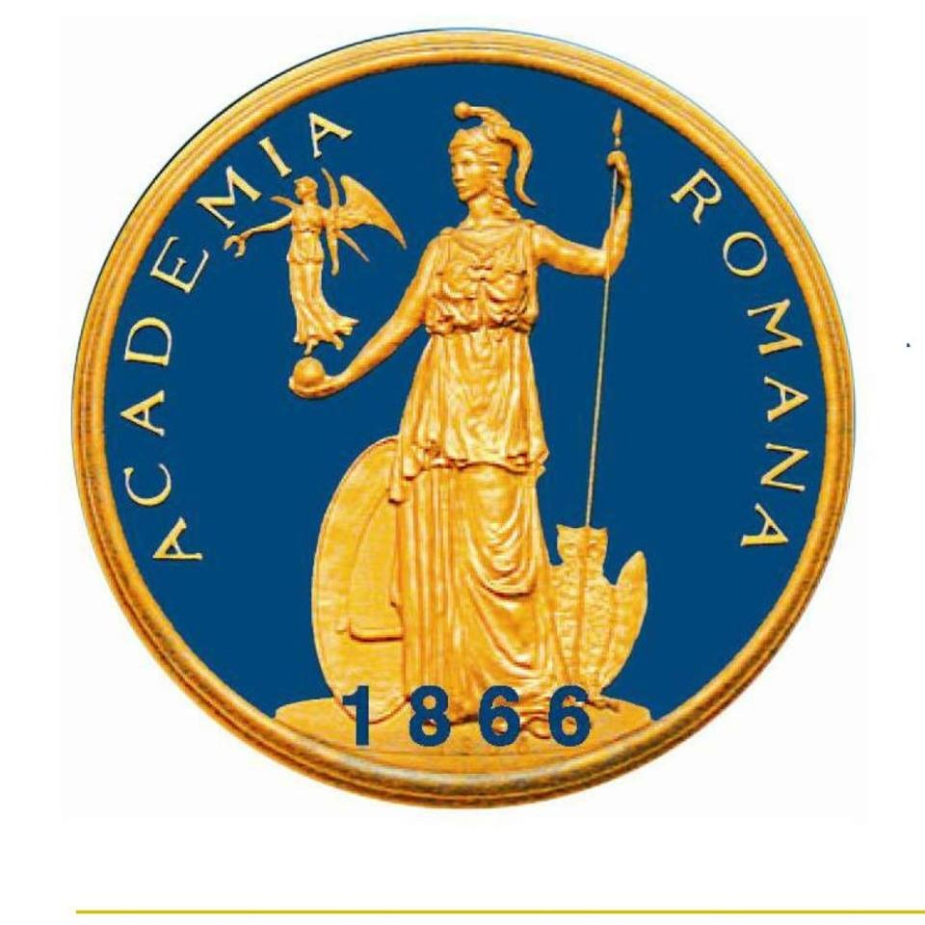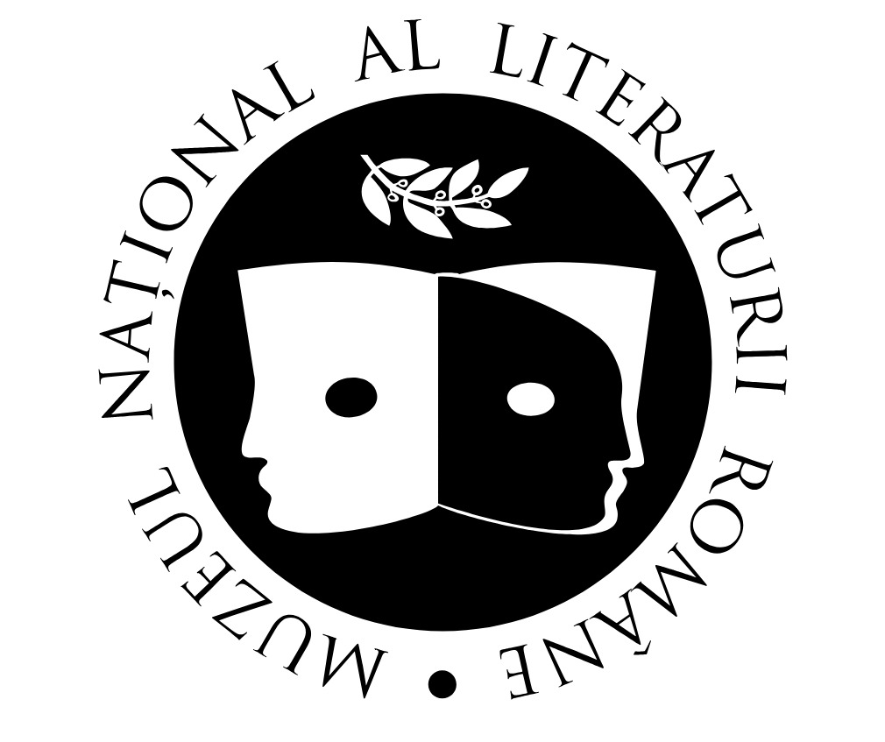
Institute for Literary History and Theory “G. Călinescu” National Museum of Romanian Literature Institute of Literature
Romanian Academy Bulgarian Academy of Sciences

INTERNATIONAL CONFERENCE

CULTURAL INFLUENCES
AND TYPOLOGICAL PHENOMENA
IN SOUTH-EASTERN EUROPEAN LITERATURES
(14TH – 18TH CENTURIES)

26 OCTOBER 2026
BUCHAREST

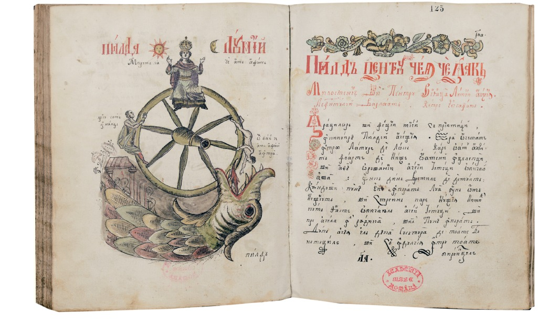

PROGRAME
ONLINE
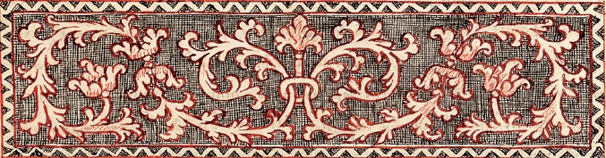

Institute for Literary History and Theory “G. Călinescu”
Romanian Academy

Link: https://us06web.zoom.us/j/82519509647?pwd=892keEXc50xrBlphZd8jgkWZIf15uE.1
meeting id: 825 1950 9647 pass: 958115

10.30 – 12.30
WELCOMING & SPEECHES PLENARY SESSION

CS I habil. Laura Bădescu, Director of The Institute for Literary History and Theory “G. Călinescu”
Assoc. Prof. Maya Yordanova Petrova-Taneva, Institute of literature, Bulgarian Academy of Sciences
Prof. habil. Ioan Cristescu, Director of The National Museum of Romanian Literature

Chair: Maya Yordanova Petrova-Taneva, Institute of Literature – Bulgarian Academy of Sciences

Maya Yordanova Petrova-Taneva, Institute of Literature – Bulgarian Academy of Sciences, Three Closely Related Manuscripts as Evidence of Bulgarian–Moldavian Literary Contacts in the 15th–16th Centuries
Radoslava Stankova, Institute of Literature – Bulgarian Academy of Sciences, Cyrillic Manuscripts in the Library of the Romanian Academy Containing Texts about Saint Petka of Tarnovo (Paraskeva of Epibatai)
Dilyana Radoslavova, Institute of Literature – Bulgarian Academy of Sciences, Influences from Across the Danube on the 17th Century Bulgarian Letters
Irina Kuzidova, Institute of Literature – Bulgarian Academy of Sciences, Slavonic Medical Texts in Manuscripts of Moldavian Origin
Ekaterina Todorova, Institute of Literature – Bulgarian Academy of Sciences, The Divinatory Book Brontologion in the Slavic-Romanian Miscellany from Putna Monastery (16th–17th Centuries): Preliminary Notes.
Elisaveta Nencheva, Institute of Literature – Bulgarian Academy of Sciences, Manuscript No. 700 from the Dragomirna Monastery in the Context of the Most Closely Related South Slavic (Bulgarian and Serbian) Codices
Nikoleta Patova, Institute of Literature – Bulgarian Academy of Sciences, Petar Beron in Wallachia

12.30 –13.00 Cofee break

13.00 – 15.00
Chair: Dorin Garofeanu, Institute for Literary History and Theory “G. Călinescu” – Romanian Academy

Laura Bădescu, Institute for Literary History and Theory “G. Călinescu” – Romanian Academy, Vechi paradigme ale cercetării slavonismului în cercetarea românească. Interogații necesare [Old Paradigms in the Romanian Study of Slavonism: Necessary Inquiries]
Ioan Cristescu, National Museum of Romanian Literature, The Origins of Illustration in Medieval Manuscripts
Aliona Grati, State University of Moldova, Receptare și transpunere culturală: literatura veche în imaginarul contemporan al sud-estului Europei [Cultural Reception and Transposition: Early Literature in the Contemporary Imaginary of Southeastern Europe]
Nicoleta Ifrim, “Dunărea de Jos” University of Galaţi, “Artistic Intelligence”: Harnessing the Power of the Arts to Address Complex Challenges Related to Cultural Influences in South-Eastern European Literatures – Culture, Creativity and Inclusive Society 2026 (HORIZON-CL2-2026-01) Project Opportunities
Virginia Popović, University of Novi Sad, La confluența a două lumi: relațiile româno-sârbe în contextul istoric și cultural al secolelor XIV–XVII [At the Confluence of Two Worlds: Romanian–Serbian Relations in the Historical and Cultural Context of the 14th–17th Centuries]
Manuela Anton, Institute for Literary History and Theory “G. Călinescu” – Romanian Academy, A Look into Paolo Grillo’s “Le porte del mondo. L’Europa e la globalizzazione medievale”
Dorin Garofeanu, Institute for Literary History and Theory “G. Călinescu” – Romanian Academy, A Shared Apocalypse: The World Upside Down in the South Slavic and Romanian Traditions of The Twelve Dreams
Florentina Nicolae, Institute for Literary History and Theory “G. Călinescu” – Romanian Academy, “Ovidius” University of Constanta, The Depiction of Constantinople in Dimitrie Cantemir’s Works

